Did Marines Storm CIA Headquarters? Yes, They Did.
Nov 30, 2017
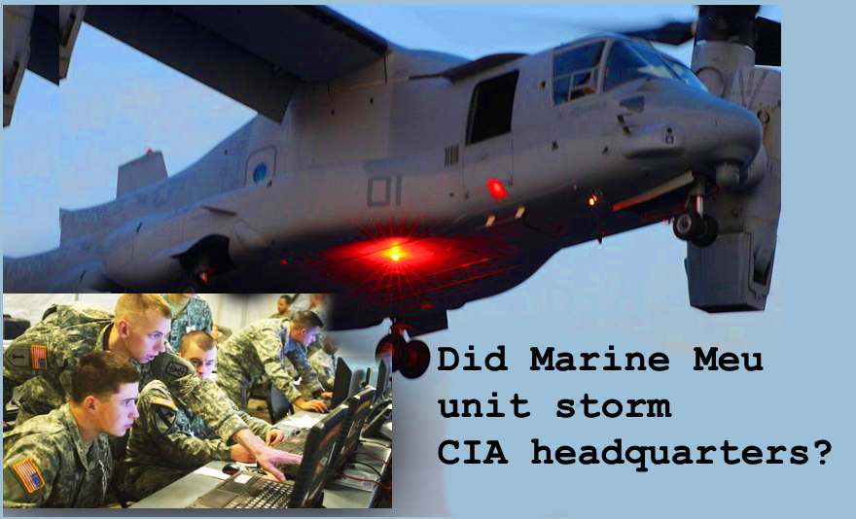
Dear Lord, please convey to us the critical moment in history we are in and put it on the heart of every Heartdweller to pray and fast for our President in this hour.

Well, my dear ones, as I've told you before, the Lord does not want me looking at new pieces or surfing around and catching up on the news. But there was an exception to this. Something that He wants to bring to your attention. And I'm going to share it with you.

First, I want to say that we do have a private source, we have a Heartdweller who is high up in the military and has privilege to a lot of information. So, he has spoken to us. None of it is classified—it's information he's put together from different sources, but they're reliable sources.

So, I had written to him and I said something in the order of, 'What is going on?? What's going on with our nation right now?' 'Cause there were some rumors that I picked up on, and the Lord took my attention and put it there and said, "I want you to listen to this."

So, I wrote to him and asked him. And he said, "There is a war going on now. Last weekend, the Marines took over the CIA, the FBI, and the NSA, and many people will go down. One of the things the Deep State has done, it has slipped "Mickeys" in the drinks of many in Congress, to take photos with underage children, to 'get the goods' on them and keep them in line. Many in Congress are CIA sponsored pedophiles. They know how to act like Christians, like the Bush's do, but like the Bush's, they are Satan-worshipping pedophiles."

And that was the beginning of the information I got from our source.

And then I checked into Hal Turner’s site, which the Lord led me to, interestingly enough.

And he had to say: "Most importantly, Pentagon sources confirm multiple Internet reports that Marines stormed the CIA headquarters this past weekend. One of the aims was to shut down Operation Mockingbird, the CIA group that turned the mass media, as well as Google, Facebook, etc. into mass mind-control propaganda, say NSA sources."

This is not my cup of tea, folks. But the Lord wanted this brought to your attention, and I’m doing it out of obedience.

Going back to my source. He said, "This is almost a winner-take-all battle. Not sure from a military point of view who will win. I know two of God's suffering servants are doing extra right now. I know that the King of Kings will prevail and clean up the cesspool. It's a very big, organized-crime cesspool with many players playing both sides in, as in Spy vs. Spy vs. Spy-type of scenario. When you see people like Hillary, McCain, etc... in walking boots, it is hide their house arrest ankle bracelets. So, of course, the mainstream media isn't reporting any of this.
But Hillary and Chelsea both have these big boots on, that look like they've broke their ankle—right? And John McCain also. It's kind of strange. And then you'll notice that they switch sides. So... first they broke their right ankle and I guess they get better overnight, and broke their left ankle? It's really hilarious...

Okay, so this paragraph is a compilation of information from a private source and what I picked up on Hal Turner's site:

"Anthony Weiner's laptop was a treasure trove of Deep State crime syndicate information, including the Clintons' sexual assault of minors and Podesta's Satanic rituals. The FBI was going to sweep it under the rug, but the NYPD got the information to WikiLeaks as a failsafe. WikiLeaks has it distributed as a failsafe, if Julian Asange is murdered. That's all I am confident about. The good guys are winning, so far, but that can change quickly."

And I asked him about Mueller because I couldn't understand the situation that he was in, and what he's exposing - who he was working for. So, I asked him about that, and he said:

"Mueller was appointed by the deputy Attorney General. Mueller has ties to the Clinton-Bush crime family, so it's no surprise he's going after President Trump. The Marine Corps is investigating everything and the Intel as of 11-29 is there are 4,286 sealed indictments"

And I had to look that up, 'cause I don't know about this stuff. A sealed indictment is when charges are brought against someone to be prosecuted, but it's not made public knowledge. It's kept secret and it's sealed. When they open it, it becomes public knowledge. I guess that's when the arrest happens.

"MS-13" he mentions in the next section. That is a notorious gang all over the world that is responsible for abducting children and, you know, distributing drugs. It's just...a horrible pit. It's all over the world.

Here he's saying, "MS-13, Clinton-Bush operatives, members of the House and Senate, state and local officials. Many will be tried by military tribunals for treason." Hallelujah! "Others for child trafficking and murder. Some for electioneering and voter fraud."

I looked up 'electioneering' and it didn't seem to be against the law. But then he said this has to do with fixing the machines, the computers and throwing the votes to the other side. That was what he was talking about.

"If President Trump, with God's help, pulls this off—America will be a nice place to live. I don't know when it will all come down, but it will be interesting if it happens. Mueller signed off on the selling of US uranium to Russia,"

And that's HUGE, guys...

"…so he's either a complete idiot or as crooked as they come. It will be very interesting to see what happens. I pray the pedophiles are all caught and put behind bars for life. The traitors should get severely punished. Every one of these criminals should have all their assets frozen and turned over to the Treasury."

Oh, and he mentions here: "There's one more thing. Mueller may be a double agent, appearing to go after Trump, but really working hard for Trump against the Deep State. Part of the Spy vs. Spy vs. Spy scenario, where no one really knows who to trust."

And when I checked Hal Turner's source, he said that there was only a show of force. And that didn't make any sense to me. I mean, these huge helicopters and MEU. MEU is a group of Marines that are highly trained. They are the ones that came in with the helicopters and were there for 30 minutes, according to the neighbors. That's from Hal Turner.

But Hal Turner's sources said they never invaded. But my source said that they did indeed. Get on the property and take a lot of records.

So, as you can see, guys - this is very, very, very serious. And coming back to what our source said:

"The Marines did raid the CIA. Crooks in DC are getting nervous because they know the big fish are in trouble. We are at the tipping point in this battle. When the mass arrests begin, it will be very sporting. There's a lot of filthy evidence on Anthony Weiner's laptop and after this much time in jail as a child molester, he's mostly likely singing.

"There are over 4,000 sealed indictments around the deep state. MS-13 being the hit squad and child kidnapping squad."

And he also talks about the need for Sanctuary Cities. And I didn't understand what that was. But a Sanctuary City is a city where the local officials refuse to cooperate with Immigration.

He also mentioned: "The CIA under Bush 41 is running drugs and reaping profits for Black ops and the Bush-Clinton crime family. Trump is bombing the drug factories and has seized assets close to $100Trillion. The 35% tax rate would change the deficit to a Surplus. He arrested the former Federal Chairman to reduce the criminal control of the money supply.

"His is a fight between good and evil and when evil is exposed, it doesn’t just give up. It becomes worse before it gets better. One thing we know for certain, truth always wins and needs no defense."

And I think that came from April LaJune. And that was Hal Turner and April LaJune, were the two people that he had cited as being fairly reliable sources. As I said, he has connections way beyond that.

"Currently, the stage is being set by the Trump Administration for the takedown of the crooks who have been in power for years. The Democrats are no longer smiling."

Yeah, this is April LaJune.

"RINOs appear nervous and those who are grinning ear to ear are the people who are on the side of good and right."

And forgive me if this is a bit spotty, because this is just too much for me to organized neatly. I have to say, on the Hal Turner blog, he mentioned that:

"According to persons who reside near Langley, a large contingent of Marines arrived at CIA Headquarters in tilt-rotor aircraft and when the Marines deplaned, they were armed and moved quickly into CIA Headquarters!" Then he said, "I did not personally witness this and am relying solely on what witnesses are telling me. Those witnesses also say that a significant number of tilt-rotor aircraft could be clearly seen circling the grounds of CIA Headquarters, parked on the grass around the building.
This is not normal.

"Never before has anything like this ever been seen taking place at CIA Headquarters and speculation is now running rampant as to what is actually taking place.

"Conspiracy Theorists are claiming the President of the United States is moving to take out rogue elements in the Intelligence Community, at the request of his new CIA Director. It is rumored that these rogue elements have been undermining the Administration since before it took office last January…”

Well, we all know that...

"...and may be connected to some well-publicized "incidents" which suddenly resumed taking place this year, (mass shootings / violent protests) after a brief respite once the Obama Administration left office.
Moreover, there is not one word of Marines landing at Langley, appearing in ANY US mass-media outlet."

Of course not!

So. The Lord is call for our prayers. He wants us backing the President. He wants us backing everything the President is doing. And the success and the outcome of these things that he's doing depends on our prayers.

So please, Heartdwellers. Please, take this to prayer very seriously. Pray for protection for all the people involved. Pray for wisdom. Pray in TONGUES. Because the Lord knows what prayers need to come out of our mouths. Pray in tongues. Stay in an attitude of alertness, because we don't know what's going to happen next.

We're talking about 4,000... over 4,000 people, highly placed in the government. State, local, Federal government that are going to be put in jail! They're indicted, they're going to be tried, found guilty - 'cause the evidence is amazingly overwhelming. And they're going to be put in jail. There are going to be holes in our government. There are going to be things missing, people missing. Special elements missing. And those have to be filled.

So, let's also pray that the Lord will supply what our government needs to carry on with some semblance of sanity and order, while all of this is taking place. I think this is one of the things that was planned for December, and that's why a lot of people were getting 'buzzed' about December. Spiritually 'buzzed' about December. Because this whole, rotten, disgusting, pedophile, drug-dealing, murderous government is being overturned. It's being turned upside-down and cleaned out. As I'd mentioned yesterday the Lord said, "It's not a swamp. It's more like the Great Lakes that are being cleaned out!'

So, you know there's an opportunity for things to be destabilized.

Now. I sought the Lord's word on the whole situation with N. Korea, with them firing a missile yesterday. A warhead that's capable of reaching anywhere in the world. I sought the Lord, because... I guess I checked on the Hal Turner station, and he was really encouraging people to get ready for war.

But this is what the Lord says.

"There is not going to be a war. I give you my solemn word on that. No war. This will not happen; it cannot happen, because My Father will not allow it. No matter what kind of show Kim gives, he is NOT God. He may think he is, a supreme being above all others, but in actuality he is a very little man in pants that are way too big for him and they are coming down to expose his nakedness.

"And that’s a fact.

"There will be no war at this time, Clare. How could I carry through with all that is set before you and the people I have been bringing along on the Channel? How could I allow war at this time?

"Yes, this would fit Obama’s agenda to a “T” but neither is Obama God, though he would like to proclaim himself as such.

"There is way too much to be done. It has been begun and it will be finished. What I have done and am doing with this country will come to completion. I just need for you all to be on the alert and pray for your president.

"This is the real crisis, not the little man with a hot button. He is beyond pitiful, Clare, way beyond pitiful and he is going to be taken out of the way. The Korean people, too, are slated for revival. They have cried out and My Father has heard them. They indeed will be added to the Kingdom.

"You can look all you want to at news sources. Of course, I don't WANT you to! But remember I have the final say. "

And then He added for a little extra here, "Have I been with you this long and ever deceived you? Have I allowed you to be crushed into fine powder…"

(which is what happened the past two days...)

"... just to completely flush you down the drain, discredit My ministry through you and disappoint all those who are praying for you and believe I am speaking through you? Is this the kind of God you serve? Certainly not. There are difficult times ahead, but no war."

And at that point, He said, "I want to enlist every dedicated prayer warrior with the facts and this will be over soon. I need knees on the ground, backing your president’s every move.

"SO MUCH depends on prayer."

And that was the end of His message. I like His little play on words, 'I need KNEES on the ground.' Not boots on the ground. Praise God. He's so wonderful!

So. No nuclear war, guys. Nobody knows what's going to happen, but the Father has it in control. And the Lord is calling us to pray that everything Trump puts his hand to will succeed. Will just come off like clockwork and succeed.

Pray for him. Pray for him. Pray for him!

Thank you, dear Heartdwellers. We love you. Let's get to prayer.

And I just wanted to mention this. A lot of people have been talking about events in December and around Christmastime. And I just want to say that there IS a possibility that the Deep State will try and pull off some kind of big event in the continental United States, to cause a diversion away from what's going on with them.

So, if it does happen, it may very well come from within. Just be aware, if something does happen, God is STILL in control!

